**SJ CUP**

**T-Shirt Pre Order Form**

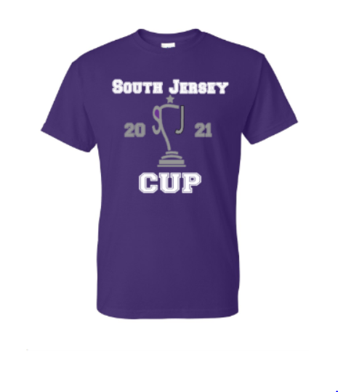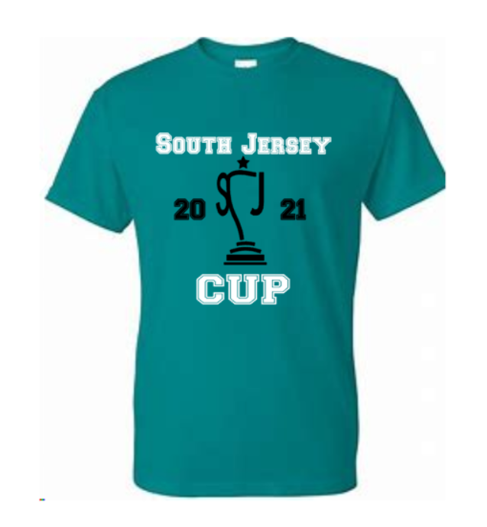

**Use the google form link to place orders:** [**https://forms.gle/oAy96AfpDHtNjcJh6**](https://forms.gle/oAy96AfpDHtNjcJh6)

***\*\*All shirts will be available for pickup at our semi-final and final events in April/May. We will contact you once they are ready with exact location.***